SAVEETHA SCHOOL OF ENGINEERING

CAPSTONE PROJECT

Optimization of network performance through dynamic routing algorithm using packet tracer

**NAME:** K. KRISHNA CHARAN

**REGISTER NUMBER: 192311316**

**COURSE CODE: CSA0747**

**COURSE NAME: COMPUTER NETWORKS FOR IOT**

**INTRODUCTION:**

This project explores the optimization of network performance through dynamic routing algorithms, specifically focusing on OSPF (Open Shortest Path First) and EIGRP (Enhanced Interior Gateway Routing Protocol). By leveraging Cisco Packet Tracer, a powerful network simulation tool, students will design and configure LANs and WANs, applying dynamic routing protocols to enhance the efficiency of data transmission. The project aims to demonstrate how dynamic routing can adapt to real-time network conditions, improving traffic flow and ensuring end-to-end connectivity between network devices.

**OBJECTIVES:**

* To design and configure LANs and WANs using Cisco Packet Tracer.
* To implement OSPF and EIGRP dynamic routing protocols in network simulation.
* To analyze the performance of networks using dynamic routing for optimized data transmission.
* To understand how dynamic routing adapts to real-time network conditions.
* To evaluate the efficiency of OSPF and EIGRP in maintaining end-to-end connectivity.
* To compare the effectiveness of OSPF and EIGRP in different network scenarios.
* To demonstrate improvements in traffic flow using dynamic routing algorithms.

**Literature Review:**

Dynamic routing algorithms have significantly advanced network performance by automatically adjusting to changes in topology and traffic conditions. Foundational work on routing algorithms by Bellman (1957) and Ford (1956) set the stage for modern dynamic protocols like OSPF and EIGRP, which optimize routing paths based on real-time information. OSPF, a link-state protocol, efficiently handles large networks, while EIGRP, a hybrid protocol, offers faster convergence. Studies comparing these protocols show that OSPF is better suited for large-scale networks, while EIGRP excels in smaller environments. Network simulation tools such as Packet Tracer have proven instrumental in teaching and experimenting with these protocols, offering a hands-on learning platform for students.

**Methodology:**

**Software**

* **Cisco Packet Tracer**: The primary software tool used to simulate the network design and implement dynamic routing protocols.

**Network Design**

The network topology consists of:

* 3 routers
* 2 switches
* 2 pc’s

**IP Address Allocation:**

* **PC 0 IP address:** 192.168.1.2
* **PC 1 IP address:** 155.165.1.0

Routing Information Protocol (RIP) Configuration:

1. Router1: Enable RIP and advertise the 192.168.10.0 and 192.168.20.0 networks.
2. Router2: Enable RIP and advertise the 192.168.30.0, 192.168.40.0, and the external 10.0.0.0 and 20.0.0.0 networks.
3. Router3: Enable RIP and advertise the 192.168.50.0 network and the external 20.0.0.0 network.

HTTP Protocol:

* Protocol: HTTP will be used for web communications between PCs and servers.
* Stateless: Each request-response interaction between client and server is independent.

**RESULT:**

**Network Design:**

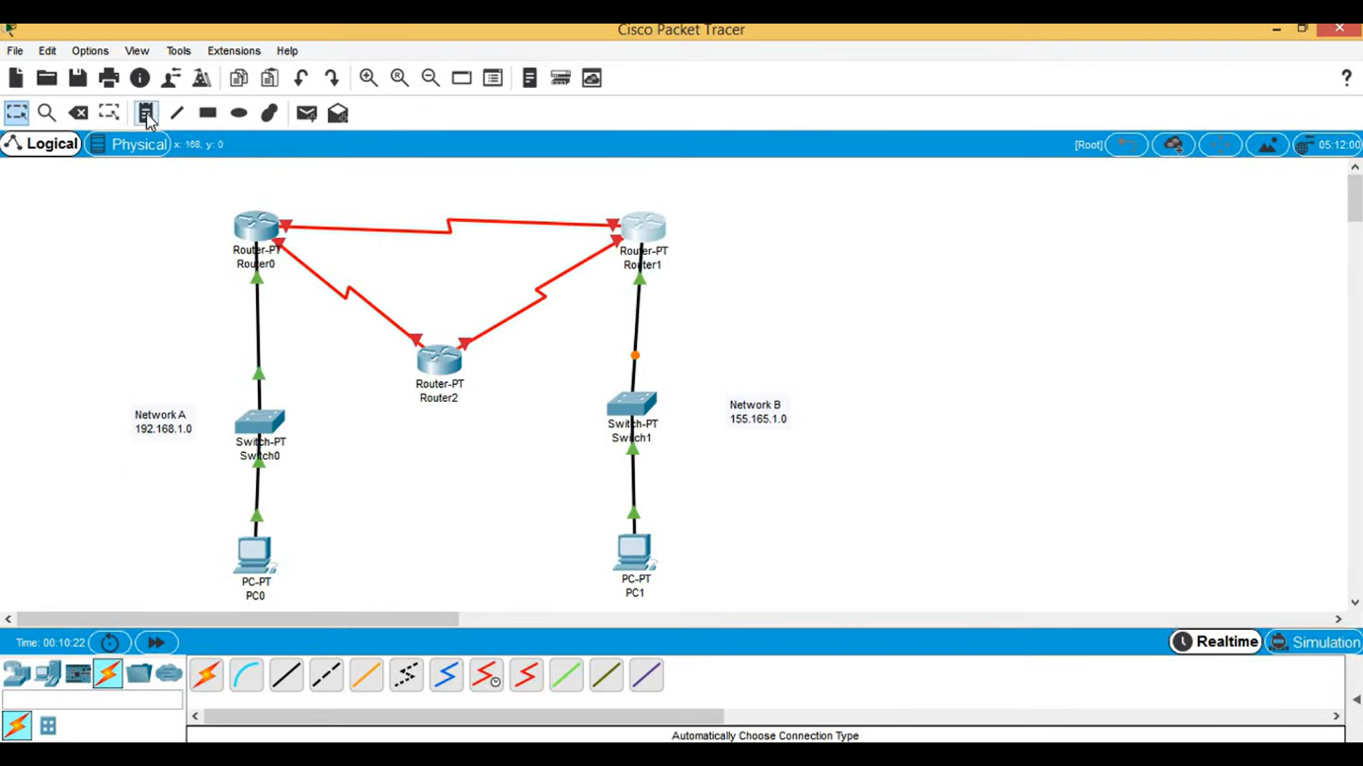

**open pc -> desktop -> ip configuration**

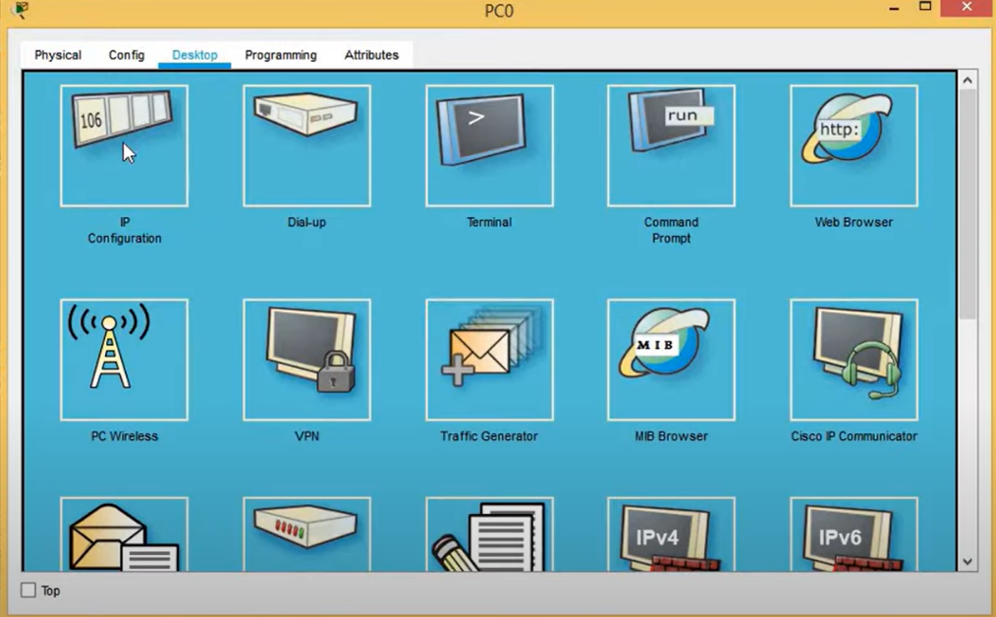

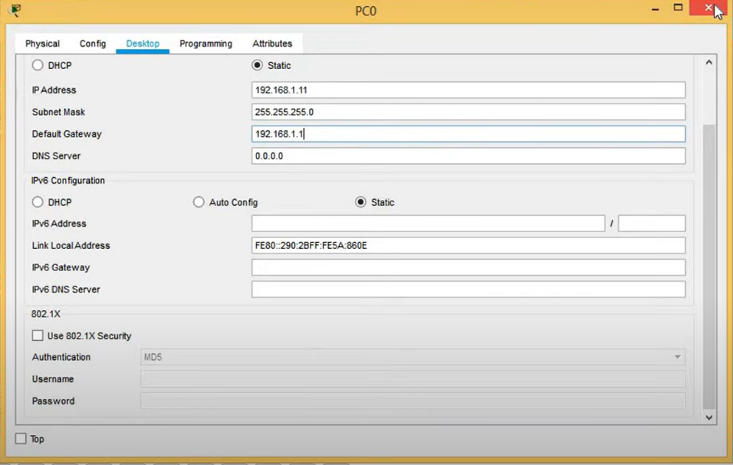

**Open router -> config**

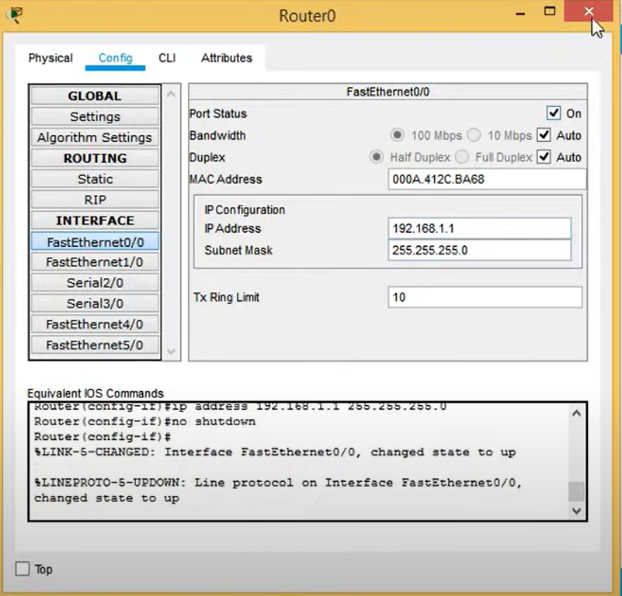

**CONCLUSION:**

Cisco Packet Tracer is a powerful network simulation tool that allows users to model, configure, and analyze network behaviors. While it doesn't deploy real-world routing algorithms or online services directly, it offers a robust platform for simulating and understanding complex network interactions.

Here's a summary of what you can achieve with Cisco Packet Tracer regarding IP address allocation and dynamic routing algorithms:

* **Simulate Network Topologies**: You can create various network setups with routers, switches, and devices to explore different IP allocation schemes and routing protocols.
* **Dynamic Routing with RIP**: Packet Tracer allows you to implement Routing Information Protocol (RIP) to automatically share routing tables between routers, optimizing network performance by enabling dynamic path selection.
* **Understand IP Address Allocation**: By allocating IP addresses to routers, PCs, and servers in different subnets, you can observe how data packets move within and between networks using dynamic routing.